**A**

**PROJECT REPORT**

**ON**

**“NGO MANAGEMENT SYSTEM”**

SUBMITTED BY:

**Miss. Maitreyee Ramesh Dukare**

SUBJECT:

**CORE CPP**

**PROGRAMMING**

Under the guidance of

**Miss. ISHWARI TIRSE**



**Department of Computer Science and Engineering**

**Sanjivani Rural Education Society’s**

**SANJIVANI UNIVERSITY**

**KOPARGAON- 423603, DIST : AHMEDNAGAR**

**2024-20225**

**INDEX**

|  |  |  |
| --- | --- | --- |
| **SR.**  **NO** | **CONTENT** | **PAGE NO.** |
| **1.** | **INTRODUCTION** | **3** |
| **2.** | **CODE** | **4** |
| **3.** | **OUTPUT** | **11** |
| **4.** | **CONCLUSION** | **12** |

**INTRODUCTION**

In this age when non-governmental organizations stand as active participants in addressing social ills, effective management of the resource is important in order to increase the impact. The NGO Management System obtains this objective to facilitate communication, improve operations, and optimize management of resources in NGOs.

This system makes it possible to manage such NGO functions as: project, donor, volunteer, and finance management. Due to the integration of these functions in one interface, the efficiency and transparency of the operation of the organization’s processes is greatly enhanced.

CPP plays an important role in the development of NGO Management System for the various reasons like platform independence, object oriented programming, web and mobile application development, scalability, rich ecosystem, security features, etc.

**CODE**

#include <iostream>

#include <vector>

#include <string>

class Donor {

public:

std::string name;

double donationAmount;

Donor(std::string name, double amount) : name(name), donationAmount(amount) {}

};

class Volunteer {

public:

std::string name;

int hoursWorked;

Volunteer(std::string name, int hours) : name(name), hoursWorked(hours) {}

};

class NGO {

private:

std::vector<Donor> donors;

std::vector<Volunteer> volunteers;

public:

void addDonor(std::string name, double amount) {

donors.emplace_back(name, amount);

}

void addVolunteer(std::string name, int hours) {

volunteers.emplace_back(name, hours);

}

void displayDonors() {

std::cout << "\nDonors List:\n";

for (const auto& donor : donors)

{

std::cout << "Name: " << donor.name << ", Donation: $" << donor.donationAmount << "\n";

}

}

void displayVolunteers() {

std::cout << "\nVolunteers List:\n";

for (const auto& volunteer : volunteers)

{

std::cout << "Name: " << volunteer.name << ", Hours Worked: " << volunteer.hoursWorked << "\n";

}

}

};

int main() {

NGO ngo;

int choice;

do {

std::cout << "\nNGO Management System\n";

std::cout << "1. Add Donor\n";

std::cout << "2. Add Volunteer\n";

std::cout << "3. Display Donors\n";

std::cout << "4. Display Volunteers\n";

std::cout << "5. Exit\n";

std::cout << "Enter your choice: ";

std::cin >> choice;

if (choice == 1) {

std::string name;

double amount;

std::cout << "Enter Donor Name: ";

std::cin >> name;

std::cout << "Enter Donation Amount: ";

std::cin >> amount;

ngo.addDonor(name, amount);

}

else if (choice == 2) {

std::string name;

int hours;

std::cout << "Enter Volunteer Name: ";

std::cin >> name;

std::cout << "Enter Hours Worked: ";

std::cin >> hours;

ngo.addVolunteer(name, hours);

}

else if (choice == 3) {

ngo.displayDonors();

}

else if (choice == 4) {

ngo.displayVolunteers();

}

else if (choice != 5) {

std::cout << "Invalid choice! Please try again.\n";

}

}

while (choice != 5);

std::cout << "Exiting the NGO Management System.\n";

return 0;

}

**OUTPUT**

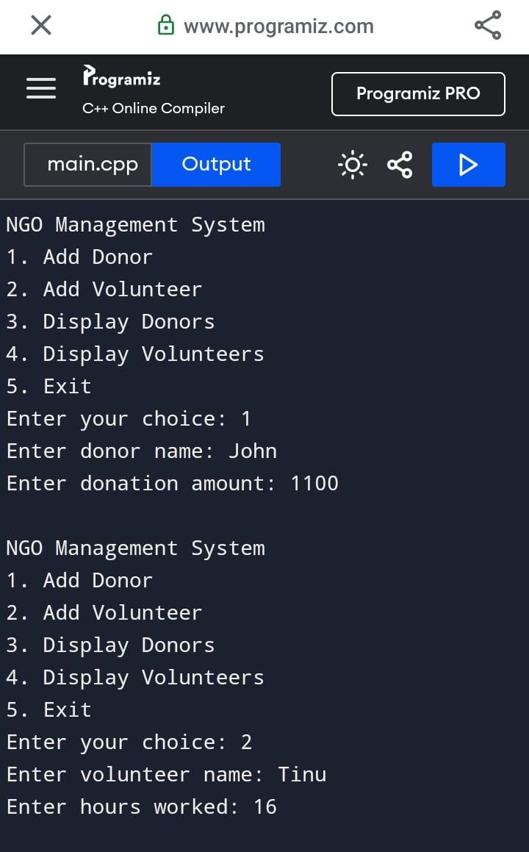

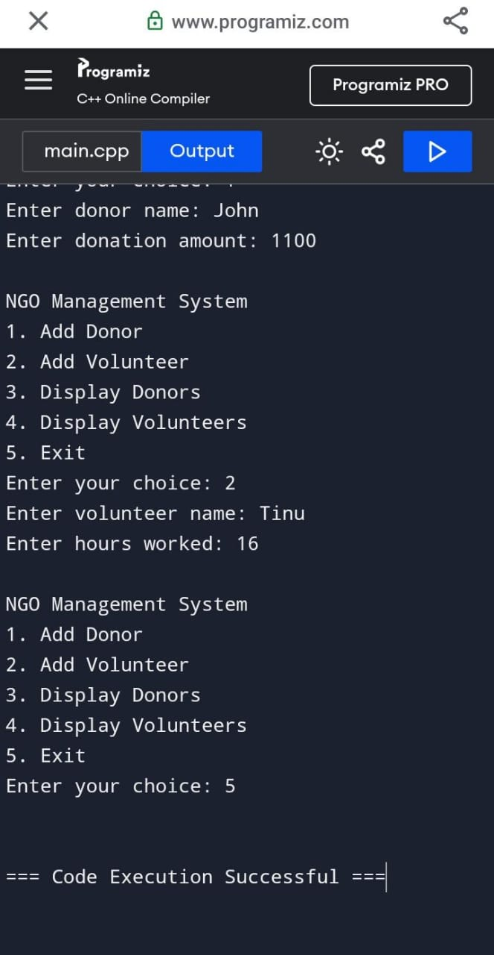

**CONCLUSION**

The NGO Management System developed in CPP serves as a comprehensive solution for non-governmental organizations to streamline their operations, enhance transparency, and improve efficiency in managing projects, donors, and volunteers. By leveraging CPP’s robust features, such as platform independence, security, and scalability, this system is equipped to meet the diverse needs of NGOs, regardless of their size or scope.